**Chapter 3 - Creative and Critical Thinking Using the Idea Database**

**Introduction**

The claim has been made that the idea database served as an important resource in developing an operational path to creative and critical thinking. In this chapter, a suggested process is explored. The rationale for this change in behavior is due to the available time and energy saved by developing a more effective data identification, capture, and organizational approach. That mechanical energy can be transformed into cognitive functions enabling a more intense consideration of the three important elements in critical and creative thinking. Those are ***measures*** used to describe attributes of characteristics, ***criteria*** used to evaluate the measures and interrelationships, and ***decision-rules*** defining behaviors based on the measures and criteria.

An important component of the operational path facilitates focus on creative and critical thinking. The objective is to identify the relevant vocabulary involved in describing a topic. As a result, new descriptions of the topic and new research strategies can be developed easier and faster. The procedure involves three steps (see Figure 1). The first involves identifying the terms making up the attributes describing the topic. Examples would be – disaster, emergency, cyclone, earthquake, etc. Surrounding this set of terms is another set representing the second identification. Those terms are identified based on ***frequency of use*** of the ideas by subject specialists and by ***consistency of use*** across the different terms making up the representation of the topic. That is, terms related to the central term. (The ***directly related*** terms.) The third set of terms is composed of those directly related to the second set and indirectly related to the topic terms. That indirect relationship is expressed by lower frequency of use of the idea involving the topic term. The third set of terms has high consistency with the terms in the direct relationship set. The result of the analysis yields a subset of the total vocabulary and that subset should be most effective in describing the idea structure representing the terms and relationships making up the topic.

**Figure 1. Identification of Relevant Vocabulary in Describing a Topic.**

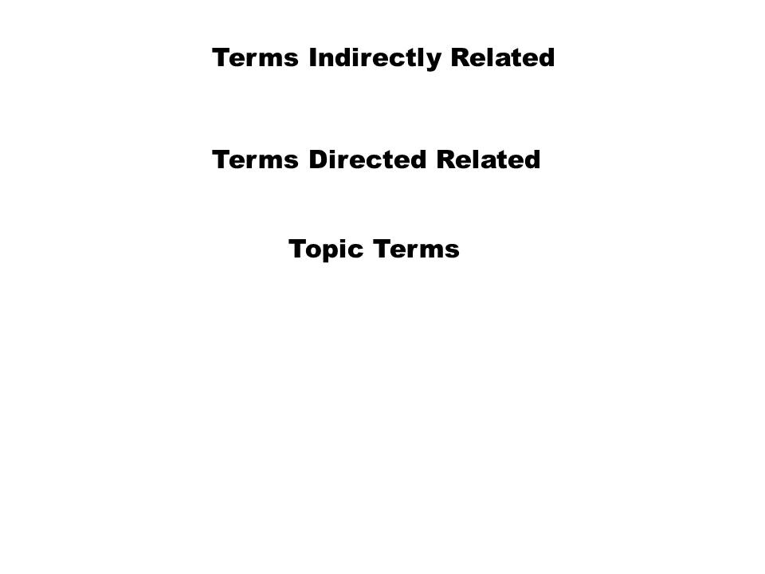

**Natural Disasters:**  An example of the process was developed using natural disasters as the topic of interest. Table 2A and 2B show the natural disasters separated into dimensions. Each type of disaster is shown as a column in the tables. The rows are the terms linked with each of the column variables and classified as representing environmental characteristics (Table 2A) or interventions (Table 2B).

The cells depict the frequency of occurrence in the disaster literature for the period 1990 – 2012. The consistency score shows the use of each idea with respect to different types of disasters. The FreqUse column shows the total use of the row variable in the different types of disasters. By sorting on the consistency, FreqUse and the alphabetical arrangement of the row terms, a representation of the consensus can be determined.

**Table 2A. Natural Disasters and Environmental Factors – 1990-2012.**

|  |  |  |  |  |  |  |  |  |  |
| --- | --- | --- | --- | --- | --- | --- | --- | --- | --- |
|  |  |  | **Environmental Factors** | | |  |  |  |  |
| **Term** | **Cyclone** | **Earthquake** | **Flood** | **Hurricane** | **Tornado** | **Tsunamis** | **Typhoon** | **Consistency** | **FreqUse** |
| **natural** | **5** | **39** | **105** | **20** | **10** | **5** | **2** | **7** | **186** |
| **public** | **3** | **29** | **77** | **33** | **2** | **2** | **3** | **7** | **149** |
| **tropical** | **15** | **1** | **17** | **7** | **3** | **2** | **2** | **7** | **47** |
| **social** | **1** | **29** | **42** | **19** | **6** | **0** | **2** | **6** | **99** |
| **community** | **1** | **20** | **50** | **14** | **5** | **0** | **1** | **6** | **91** |
| **coastal** | **6** | **9** | **38** | **5** | **2** | **2** | **0** | **6** | **62** |
| **economic** | **2** | **17** | **35** | **4** | **1** | **0** | **1** | **6** | **60** |

Etc.

**Table 2B. Natural Disasters and Interventional Factors – 1990-2012.**

|  |  |  |  |  |  |  |  |  |  |
| --- | --- | --- | --- | --- | --- | --- | --- | --- | --- |
| **Term** | **Cyclone** | **Earthquake** | **Flood** | **Hurricane** | **Tornado** | **Tsunamis** | **Typhoon** | **Consistency** | **FreqUse** |
| **cause** | **5** | **106** | **199** | **25** | **22** | **4** | **1** | **7** | **362** |
| **medical** | **1** | **123** | **24** | **31** | **11** | **1** | **1** | **7** | **192** |
| **provide** | **3** | **70** | **78** | **39** | **4** | **3** | **0** | **6** | **197** |
| **management** | **1** | **32** | **75** | **2** | **1** | **1** | **0** | **6** | **112** |
| **evacuation** | **1** | **10** | **23** | **34** | **1** | **0** | **2** | **6** | **71** |
| **service** | **0** | **27** | **13** | **13** | **5** | **1** | **1** | **6** | **60** |
| **reduce** | **1** | **8** | **30** | **2** | **1** | **0** | **2** | **6** | **44** |

Etc.

Table 2B shows an excerpt from the ideas linking interventional factors with the different types of natural disasters. The row variables are sorted by consistency, FreqUse, and alphabetical arrangement of the row terms.

Table 3A shows the interventional factors linked with the row variables (Tables 2A and 2B) and Table 3B shows the outcome factors linked with the same variables. These row variables are examples of the direct relationship set and were selected because of high frequency of links with the different forms of disaster (topic set).

Suppose that communication ideas are considered. The relationships between communication and the different natural disasters were below the level set for direct relationships. However, the relationships between communication and the second selection variables were satisfied. The consistency score was 9 and the frequency of use for communication was 265 (see Table 3A), a moderate score. ***Communication*** (an intervention factor) with ***Response*** (an outcome factor) was observed 24 times in the period 1990 – 2012.

**Table 3A. Second Selection Interventional Factors – Consistency Score 9.**

|  |  |  |  |  |  |  |  |  |  |  |
| --- | --- | --- | --- | --- | --- | --- | --- | --- | --- | --- |
| **Term** | **Natural** | **Tropical** | **Public** | **Medical** | **Evacuation** | **Management** | **Provide** | **Reduce** | **Service** | **FreqUse** |
| **hospital** | **16** | **2** | **81** | **479** | **57** | **181** | **262** | **37** | **100** | **1215** |
| **clinic** | **40** | **2** | **74** | **313** | **8** | **302** | **303** | **26** | **57** | **1125** |
| **treatment** | **29** | **2** | **30** | **369** | **21** | **167** | **223** | **60** | **38** | **939** |
| **training** | **12** | **3** | **79** | **246** | **14** | **107** | **214** | **19** | **28** | **722** |
| **control** | **48** | **2** | **88** | **149** | **17** | **133** | **145** | **28** | **24** | **634** |
| **development** | **46** | **1** | **63** | **87** | **3** | **73** | **110** | **13** | **20** | **416** |
| **medicine** | **10** | **1** | **24** | **149** | **3** | **37** | **65** | **5** | **16** | **310** |
| **communication** | **12** | **1** | **49** | **59** | **13** | **50** | **58** | **11** | **12** | **265** |
| **prevent** | **17** | **1** | **35** | **47** | **5** | **48** | **39** | **30** | **11** | **233** |
| **surgery** | **3** | **1** | **1** | **69** | **5** | **65** | **35** | **14** | **15** | **208** |
| **supplies** | **4** | **1** | **5** | **53** | **7** | **8** | **24** | **3** | **3** | **108** |
| **deployment** | **3** | **1** | **3** | **47** | **1** | **11** | **21** | **2** | **6** | **95** |
| **resuscitation** | **3** | **1** | **2** | **25** | **9** | **14** | **23** | **4** | **3** | **84** |

Etc.

**Table 3B. Second Selection Outcome Factors – Consistency Score 9.**

|  |  |  |  |  |  |  |  |  |  |  |
| --- | --- | --- | --- | --- | --- | --- | --- | --- | --- | --- |
| **Term** | **Natural** | **Tropical** | **Public** | **Medical** | **Evacuation** | **Management** | **Provide** | **Reduce** | **Service** | **FreqUse** |
| **health** | **229** | **8** | **1437** | **544** | **38** | **293** | **863** | **66** | **282** | **3760** |
| **response** | **109** | **3** | **230** | **411** | **27** | **144** | **339** | **25** | **59** | **1347** |
| **mental** | **132** | **3** | **156** | **132** | **19** | **129** | **269** | **46** | **106** | **992** |
| **important** | **66** | **9** | **70** | **119** | **16** | **107** | **128** | **15** | **22** | **552** |
| **mortal** | **46** | **10** | **41** | **94** | **15** | **77** | **46** | **127** | **7** | **463** |
| **critical** | **21** | **1** | **46** | **116** | **14** | **83** | **116** | **10** | **7** | **414** |
| **death** | **51** | **3** | **38** | **105** | **11** | **31** | **51** | **25** | **7** | **322** |
| **quality** | **15** | **2** | **28** | **75** | **3** | **70** | **88** | **12** | **28** | **321** |
| **injuries** | **27** | **2** | **12** | **105** | **11** | **97** | **45** | **14** | **7** | **320** |
| **morbid** | **34** | **2** | **25** | **66** | **4** | **51** | **32** | **73** | **8** | **295** |
| **benefit** | **13** | **1** | **35** | **52** | **8** | **44** | **88** | **10** | **10** | **261** |
| **exposure** | **63** | **2** | **34** | **43** | **8** | **13** | **53** | **21** | **8** | **245** |

Etc.

Table 4 shows the terms that could be included in research studies involving communication.

**Table 4. Terms Related to Communication in Developing Research Designs.**

|  |  |  |  |  |  |  |  |  |
| --- | --- | --- | --- | --- | --- | --- | --- | --- |
|  |  |  |  |  |  |  |  |  |
|  | **Personal** |  | **Subject** |  | **Intervention** | | **Outcome** |  |
|  | civilian |  | accident |  | clinic |  | benefit |  |
|  | people |  | attack |  | control |  | critical |  |
|  | person |  | cause |  | deployment | | damage |  |
|  | poor |  | chemical | | development | | exposure | |
|  | race |  | danger |  | doctor |  | fatal |  |
|  | worker |  | disaster |  | hospital |  | health |  |
|  |  |  | disease |  | medicine | | importance | |
|  | **Environmental** | | disorder |  | prevent |  | important | |
|  | community | | earthquake | | resuscitation | | improvement | |
|  | district |  | emergencies | | supplies |  | improving | |
|  | field |  | emergency | | training |  | living |  |
|  | global |  | flood |  | treatment | | loss |  |
|  | location |  | hazard |  |  |  | magnitude | |
|  | organization | | hurricane | |  |  | mental |  |
|  | population | | infection | |  |  | morbid |  |
|  | social |  | infectious | |  |  | mortal |  |
|  | structure | | injuries |  |  |  | policy |  |
|  |  |  | nuclear |  |  |  | quality |  |
|  | **Methods** |  |  |  |  |  | respiratory | |
|  | analysis |  | organization | |  |  | responding | |
|  | assess |  | planning | |  |  | response | |
|  | design |  | process |  |  |  | severity |  |
|  | epidemiologic | | record |  |  |  | vulnerability | |
|  | evaluate | | research |  |  |  |  |  |
|  | evidence | | review |  |  |  |  |  |
|  | experiment | | simulation | |  |  |  |  |
|  | investigate | | skill |  |  |  |  |  |
|  | measure | | strategies | |  |  |  |  |
|  | mechanism | | trial |  |  |  |  |  |
|  | model |  |  |  |  |  |  |  |

Exhibit 1 shows one arrangement of the terms and ideas from Table 4. The central idea is – ***communication & damage***. The intervention is to develop a program designed to prevent damage due to earthquakes. The group being studied is workers. The methods involve development of models and design of new structures. Expanding the ideas with damage as the central term yields one additional idea – ***damage & devastation***. Other ideas related to damage involved terms such as construction, structure, mitigation, and reconstruction. These ideas could form sections of the program included as intervention.

**Exhibit 1. Ideas from Document 22415501 in a Research Descriptive-Intervention Template.**

**Personal Subject Intervention Outcome**

***Worker Earthquake Communication Damage***

***Prevent Devastation***

**Environment**

***Structure***

**Method**

***Design***

***Model***

Exhibit 1 was formed by choosing the outcome factors and then the intervention factors. Once those relationships were set, the subject, personal, and environmental factors could be selected. The relationship between intervention and outcome defines the methods.

**Modifying the Research Design:** Other studies dealing with the subject 🡪 intervention 🡪 outcome in Exhibit 1 could involve civilians as the group studied. Exhibit 2 shows the changes that might be made. The outcome factors could be expanded to focus on policy change. The interventional factors could be expanded to focus on a training program dealing with the problem of earthquake damage and the benefits associated with instituting new structural changes. The forms of communication also could be studied.

**Exhibit 2. Ideas from Document 22415501 in a Research Descriptive-Intervention Template.**

**Personal Subject Intervention Outcome**

***Civilian Earthquake Communication Damage***

***Prevent Devastation***

**Environment *Training* Policy**

***Organization Benefit***

**Method**

***Design***

***Model***

***Structure***

These two designs could be further modified by changing the subject factor to one or more of the other types of disasters. The value of each design could be assessed by developing ***measures of design efficiency, criteria for ranking the designs, and decision-rules to describe subsequent behaviors.***

**Using an Algorithmic Approach to Assist in Creative and Critical Thinking:** Traditionally, creative and critical thinking have been regarded as behaviors restricted to the capabilities of the individual. A common assumption has been that the individual possessed inheritable characteristics that made these intellectual activities possible and effective. If those perceptions were true, the delays in dealing with complex problems could be explained in terms of waiting for the genius interested in the problem and willing to solve it.

If however, critical and creative thinking is a learned behavior, then the number of individuals performing such behavior could markedly increase. The focus on ideas and their innate ability to be combined in a variety of ways, suggest that algorithms could be developed to assist the individual in producing the varied arrangements of ideas and in choosing the arrangement offering maximal success.

Bloom’s Taxonomy of Learning suggests that the cognitive functions making up the learning process can be considered separately. Each function could be divided into three components – development of ***measures*** describing attributes of characteristics involved in the function; development of ***criteria*** for dealing with the results of those measures; and development of ***decision-rules*** for instituting specific reactions or behaviors. These possibilities plus the independence of ideas give justification for attempting to construct operational translations of the cognitive functions.

The process employing algorithms involves the following steps:

1. Select terms representing the different situations to be considered. In this example, those terms describe different types of natural disasters, e.g., earthquake, flood, hurricane, etc. These are the topic terms (Figure 1).
2. Determine the ideas linked to each type of natural disaster. These will form the direct relationship set.
3. Create a matrix showing the terms involved in each type of disaster using ***Excel***. Enter the frequency of occurrence of each of the column (type of disaster) & row (directly related terms) ideas.
4. Determine the consistency score for each row idea set. Use the formula -- ***=countif(n1:n2, “>0”)*** The variables, n1 and n2, refer to beginning and ending cells in the first data row. Copy the contents of the first cell in the consistency column and highlight subsequent cells in that column by running the cursor down. The empty cells will be changed to the number indicating consistency for that row.
5. Determine the frequency of use of each row term in the column ideas. Use the formula -- ***=sum(n1:n2).*** Copy the contents of the first cell in the sum column and highlight subsequent cells in the column by running the cursor down. The empty cells will be changed to the number indicating frequency of use of ideas involving the row term.
6. Group the ideas for each row by dimension – personal, environmental, subject, intervention, outcome, and method.
7. Sort the row ideas within each dimension by consistency score and FreqUse from largest to smallest.

Those tasks enable construction of descriptions based on frequency of ideas and/or consistency of ideas for terms having a ***direct relationship*** with each of the column (topic) variables. The criterion used for selection of terms depends on the analyst. In these examples, selection of the directly related terms (Figure 1) used consistency scores of 5-7. Selection of the indirectly related terms used a consistency score of 9.

The complexity of relationships among terms suggests that there also are strong ***indirect relationships***. The selection of specific terms in this second category requires additional tasks. Those tasks would be:

1. Use the direct relationship terms as column headings in a new matrix.
2. Identify the row terms from the above matrix that have higher consistency scores irrespective of frequency of occurrence. Enter the higher consistency terms as row variables in the new matrix.
3. Construct a new matrix with the direct relationship terms as columns and the indirect related terms as rows. Enter the frequency of occurrence of each of the column & row ideas.
4. Determine the consistency score for each row variable.
5. Group the ideas for each row by dimension.
6. Sort the row ideas within each dimension by consistency score – largest to smallest.
7. Consider the high consistency terms as additions to the ideas identified from the direct relationship (first) high frequency/high consistency set.

With the terms and ideas identified, construct a series of research templates by populating the basic design. Develop measures, criteria, and decision rules using Bloom’s cognitive functions. Those functions are: comparison, evaluation, judgment, and application. This final step is the crucial one in revealing the individual’s intellectual accomplishment. It is the culmination of the individual’s inherent capabilities, the academic preparation, the learning accomplished, and the ability to develop new descriptions, study procedures, and solutions to recognized problems.

**Summary**

The examples used in this chapter show the value of the vocabulary and involved ideas in developing research strategies. The critical differences from traditional information processing included:

1. The formal process used in selection of vocabulary based on frequency and consistency of ideas.
2. The reliance on the power of ideas (i.e., combinations of informative terms within the domain of a sentence).
3. The independence of ideas enabling them to be used in a variety of ways.
4. The acceleration of creative action by eliminating the mechanical waste in traditional information processing.
5. The assumption that creative and critical thinking is a learned behavior.

The exponentially increasing volume of scholarly literature in virtually every subject requires new information processing methods. The focus on the ideas and the algorithmic approach to recognizing relevant vocabulary significantly reduce the time and energy involved in organizing the data. With those methods in place, the individual can spend essentially fulltime on the real challenges of developing new descriptions of topics and in forming new research strategies, comparing them, and choosing the most effective for translation to a working protocol.